Lab 10.2 – Exercise

Objective: Fit a boosted regression tree (BRT) model to coral occurrence data (presences and pseudo-absences) and environmental data.
Study region: Tropical Americas and Caribbean, ext(-100, -55, 0, 32)
Instructions
- Follow the steps in the PowerPoint (slides 16 to 25) to build a species distribution model (SDM) for corals using pseudo-absences. The only thing you need to change is the study area extent: replace the Coral Triangle extent (slide 19) with ext(-100, -55, 0, 32) for the Tropical Americas and Caribbean.
- All the data you need is in the folder Sci_Comp26.
- Each time you start a new R session, load the packages again (for example, library(terra)). You do not need to reinstall them.
- Turn in a screenshot of your RStudio window showing both your script and the predicted species distribution map. The example below is for the Coral Triangle; yours should show the Tropical Americas and Caribbean.
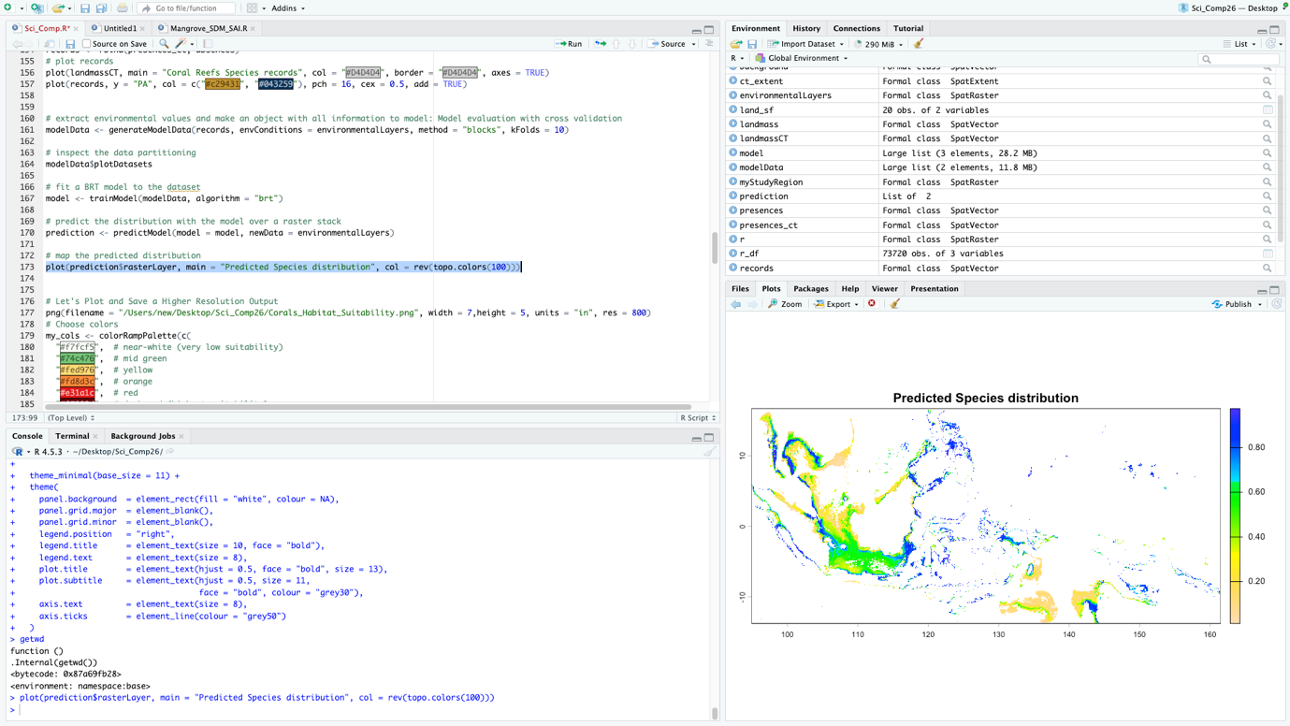

Packages, data, and function to accomplish the challenge:
Files to use
"occurrenceRecords.csv"
"Present Benthic OceanTemperature LtMax.tif”"
"Present Benthic OceanTemperature LtMin.tif”"
"Present Benthic pH Mean.tif”"
“Present Benthic Salinity Mean.tif”
“Present Surface OceanTemperature LtMax.tif”
“Present Surface OceanTemperature LtMin.tif"
Functions to use
library (if you are starting over again)
rast
plot
studyRegion
pseudoAbsences
crop
mask
generateModelData
trainModel
predictModel

